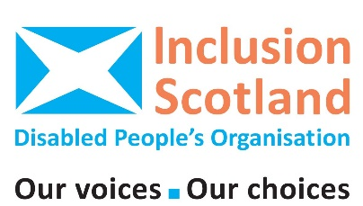
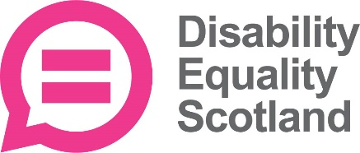
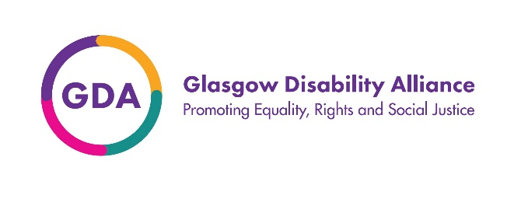

#DisabledPeopleDemandJustice

Campaign Fortnight: Tuesday 22nd Oct – Mon 4th Nov 2024
Disability Equality Scotland, Glasgow Disability Alliance, Inclusion Scotland and Disabled People-Led Organisations across Scotland are joining together for a fortnight of action and campaigning to demand justice and deliver equality for disabled people. We need your support for this critical campaign.
Disabled people are in the midst of a perfect storm: austerity measures and the impact of cuts to services, benefits and budgets, together with the Covid pandemic, have had a disproportionate effect on disabled people. Simply put, we have experienced increasing poverty and inequality and human rights regressions and have been forgotten by Governments and left behind by those in power.
- 63% of Disability Equality Scotland survey respondents use independent living or lifesaving equipment and 75% of respondents said that they were very worried about their ability to pay energy bills (Winter Fuel Fact Sheet).
- 47% of Scots disabled people reported that they were struggling to keep up with their energy bills compared with 29% of non-disabled people and 47% of Scots disabled people reported that they had cut back on food compared with 32% of non-disabled people, (Inclusion Scotland’s Fuel Poverty Briefing 2024).
Glasgow Disability Alliance’s Summer Survey of 621 disabled people paints a bleak picture requiring immediate attention and actions. In this survey 97% of disabled people were concerned they had been forgotten in Government priorities and plans. The most recent Programme for Government reveals that their concerns were valid.
A rising tide is threatening to drag disabled people under, unless urgent action is taken.
We want to ensure that the Scottish Government takes urgent and bold action so that disabled people get the essential support we are entitled to.
- Disabled people make up 27% of the population in Scotland (October 2024 House of Commons https://researchbriefings.files.parliament.uk/documents/CBP-9602/CBP-9602.pdf
- Scotland’s Census 2022 found that the percentage of people reporting a long-term illness, disease or condition increased from 18.7% in 2011 to 21.4% in 2022 . Numbers reporting mental health condition have doubled and figures are still being analysed for people with learning disabilities/learning difficulties and developmental disorders so the total is higher than is currently known.
For too long now disabled people have been denied basic rights that everyone else takes for granted – because the vital supports we need are missing; because policy incoherence deepens the poverty and inequality we face e.g. social care charges and because there is a lack of willingness to take action.
This is why Disability Scotland, Glasgow Disability Alliance and Inclusion Scotland have worked tirelessly with the Scottish Government for the past 20 months: our agreed aim was to develop a bold and action focused Disability Equality Plan which would improve lives.
Despite the Programme for Government 2023 commitment to deliver an Immediate Priorities Plan to address the cost of living and energy crisis of winter 2023 and the Programme for Government 2024 promising to Deliver on a Disability Equality Plan which would ensure the voices of disabled people would be at the centre of policy and decision-making, we are still waiting.
No actions have yet been taken.
No commitment to meaningful actions has been made.
No progress towards Disabled People’s Equality.
As a result, disabled people and our DPOs are demanding justice!
The 3 DPOs leading this campaign have invested considerable time and energy to no avail. Our collaboration on an immediate priorities plan began as a genuine attempt at co-design and has ended in collapse of all promises and ambition – leaving us struggling to defend our involvement to our members, in what has turned out to be a sham process.
#DisabledPeopleDemandJustice and we are demanding the following to make that happen:
Ask 1: Increase investment in the Advice in Accessible Settings Fund to enable a focus on accessibility of existing projects providing welfare rights and debt information and support.
Why? Because disabled people are facing the rising tide of extra costs of being disabled, barriers to work, and obstacles to securing social security benefits which provide an anchor in keeping them afloat.
Ask 2: Invest in Social Care and Scrap Social Care Charges including charges applied to recipients of the Independent Living Fund.
Why? Because social care charges plunge disabled people into deeper poverty, trapping them so that they cannot pursue opportunities and choices including participation in their families, communities and wider social and civic life and also including education and work opportunities.
Ask 3: Invest in and protect funding for Disabled People’s Organisations.
Why? Because disabled people have been systematically failed by a lack of plans and actions to address poverty, inequalities and thwarted life opportunities and we are routinely excluded. DPOs offer a lifeline to disabled people, uniquely telling them about their rights and helping them to reframe their oppression and work with others towards solutions to barriers. Emancipatory approaches reframe the source of disability and participatory methods provide collective advocacy and build community and belonging – reducing extreme isolation. DPOs enshrine and uphold the world wide slogan “Nothing About Us Without Us”.
Join our campaign over the next two weeks. Share it on social media and email the First Minister to express why you are demanding justice with us.

End of document

